Monty and Rose Part 7
https://www.chicagobirder.org/plover-watch-2019/2019/6/13/shorebird-rock-stars-original-post-april-15-2019-wh4x7?fbclid=IwAR2LiwxyENdDnYK6A5d1UMQxXceGPs_zh_XAixRXChYfQP3HiVsrr6qG0ts
This is a repost from the COS blog that originally was posted on April 15, 2019. At that time, we were coming off of the excitement that was Dodger the Piping Plover who stayed at Montrose Beach well passed his migration bedtime. We had no idea what was about to happen a mere two months after this was posted. We will be revisiting all of the information contained here at the end of the 2019 season, but for now, please enjoy this background information and context for this roller coaster of a summer.
Piping Plovers have taken quite the spotlight this winter. This was especially the case when a young one decided stick it out at Montrose beach in Chicago well past the normal time frame of when they should be found there. After eluding capture by authorities at least three times, Dodger, as it became known by birders, decided to stick things out here well into December. The phenomenon bird was a big draw for birders as the bird watching options generally slowed and was something of an inspiration for many such as here on the COS blog.
If all that wasn’t exciting enough, last month, the City of Waukegan and Lake County Audubon Society announced a partnership monitoring program. The program is designed to protect and advocate for the many sensitive species, Piping Plovers being one of them, that call their beaches home.
With interest in the success of the federally endangered Great Lakes population of Piping Plover, we thought it’d be good to get a quick refresher on where they’re at going into 2019. The following 2018 update summarizing the annual report from the U.S. Fish and Wildlife Service, originally appeared in the Nov/Dec 2018 edition of The Chicago Birder, COS's bi-monthly member newsletter. For more information about this, other membership benefits, and ways your support makes our work like the following possible, take a look at our membership page.
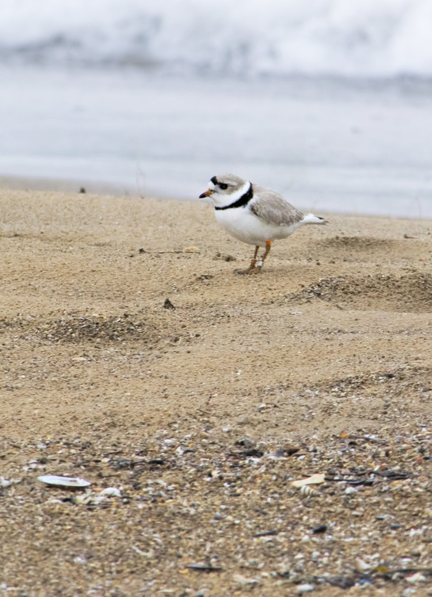
In 2018 the Great Lakes piping plover population fell to 67 pairs after several years of hovering around the 75 pair mark. After a relatively poor breeding season in 2017 (1.26 chicks fledged per pair) and an unusually cold winter season in parts of the wintering range (similar to the winter that pre-staged the 2010-11 population drop) a decline in population was not wholly unexpected. Despite the population falling, 2018 was still a successful breeding season. For the second year in a row breeding piping plovers were found on all five Great Lakes. When this happened in 2017, it was the first time there were breeding plovers on all five Great Lakes in 55 years.
The chick production in 2018 was very good at 1.84 chicks per pair fledged in the wild and 1.99 chicks fledged per pair including chicks that fledged from the salvage captive rearing program. This made 2018 the best breeding season since 2013, and one of the best years ever. Particularly good breeding success occurred at Sleeping Bear Dunes National Lakeshore which fledged a record 72 chicks, Wasaga beach in Ontario which fledged 9 chicks out of 12 eggs laid and in the eastern Lakes where nests in Pennsylvania and New York both fledged 4 chicks each.
Habitat restoration work continued to pay dividends. The Piping Plover habitat restored at Wilderness State Park in Northern Michigan had 3 piping plover pairs that fledged 4 chicks and the restored Cat Island chain also had 3 pairs that fledged 3 chicks.
Initial 2018 Breeding Season Statistics:
67 Pairs
68 nests
263 eggs laid
204 eggs hatched in the wild
123 chicks fledged in the wild
10 chicks fledged in captivity
1.84 chicks per pair fledged in the wild (recovery criteria is 1.5)
1.99 chicks per pair fledged counting captive chicks

Facebook July 25 Tamima Itani

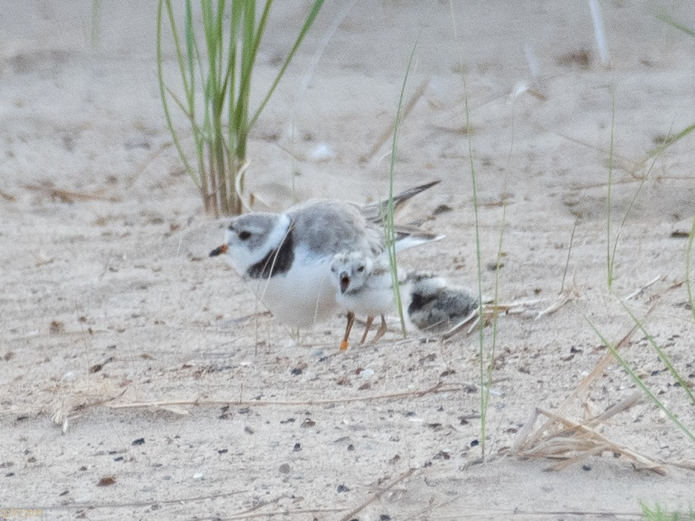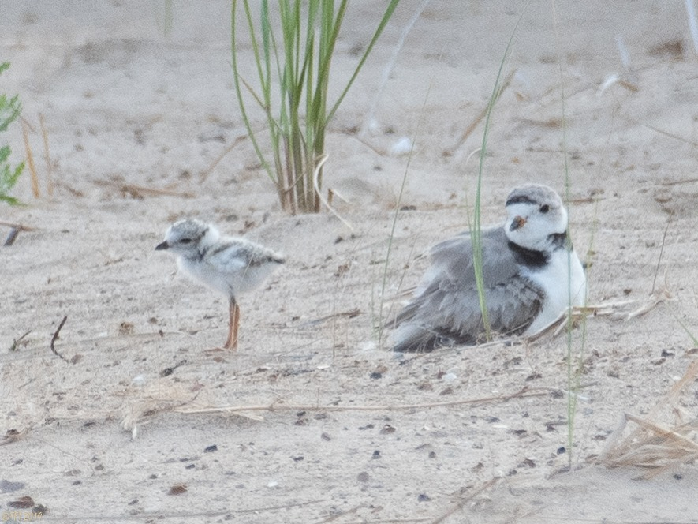
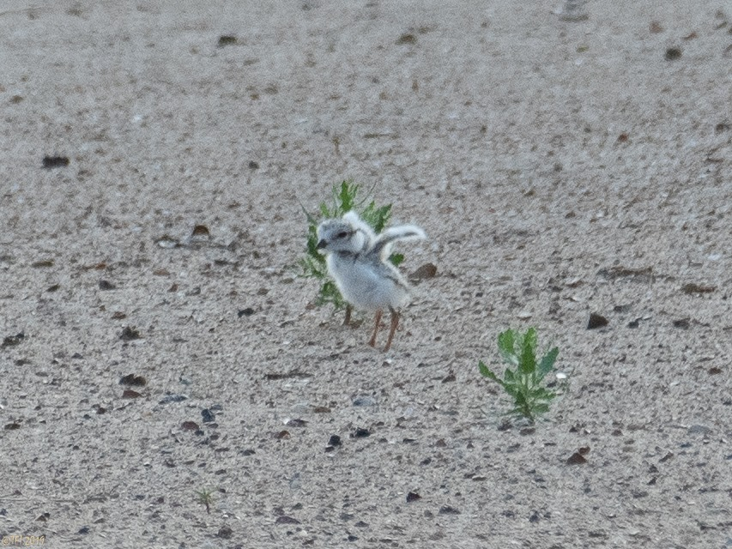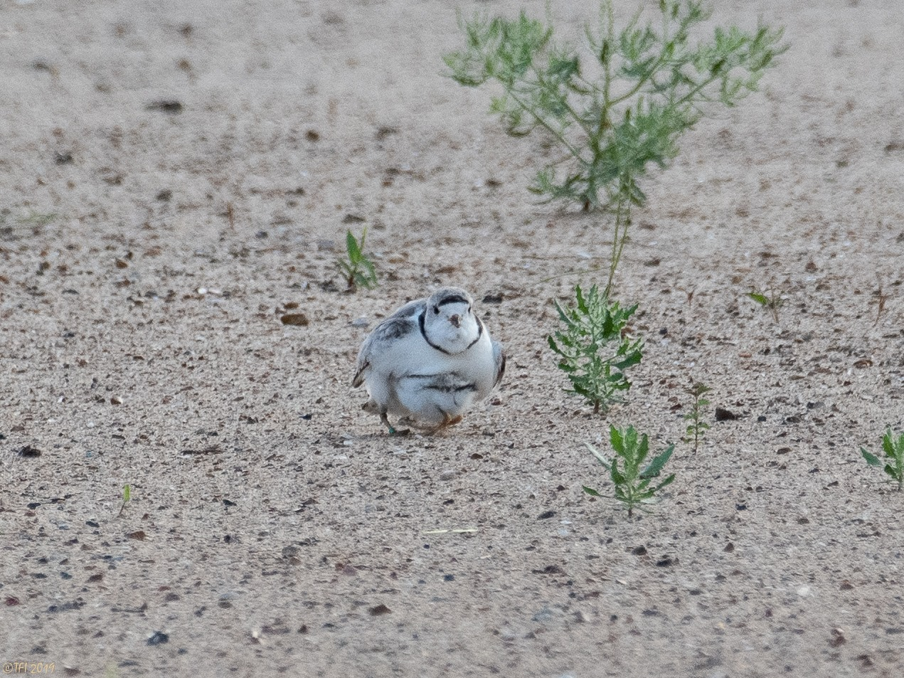

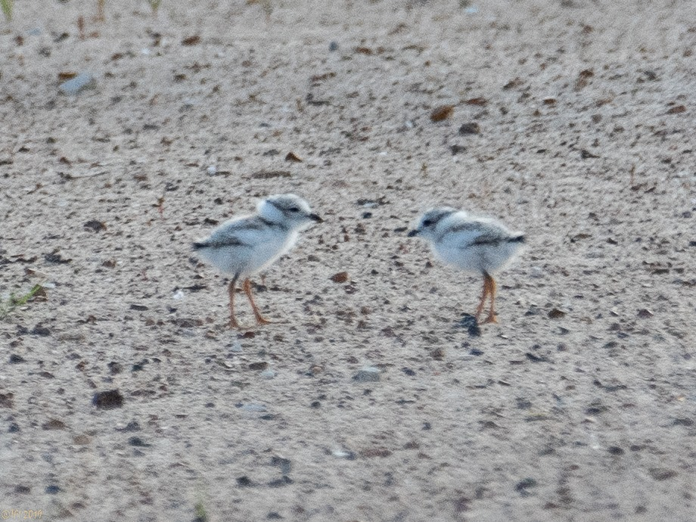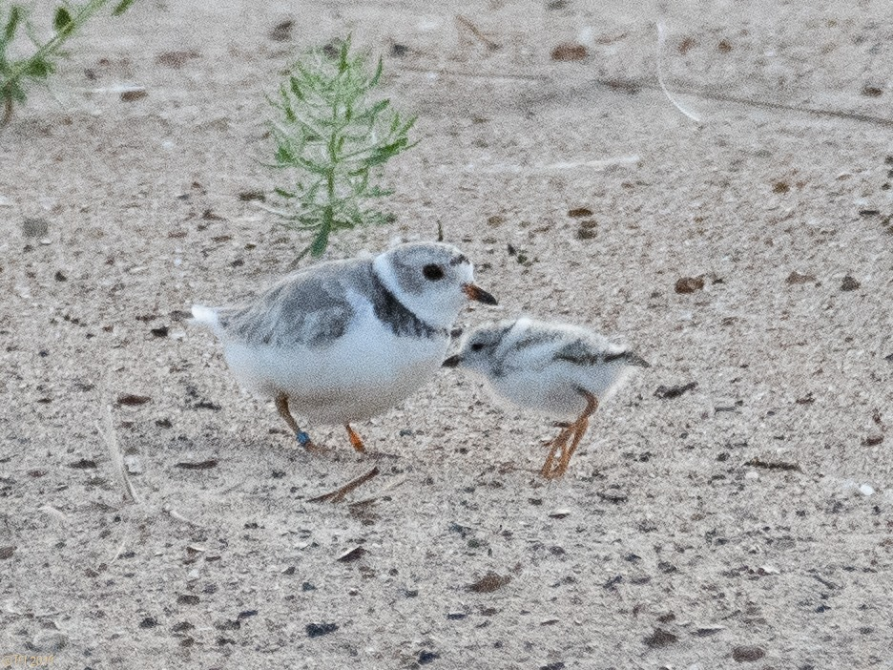

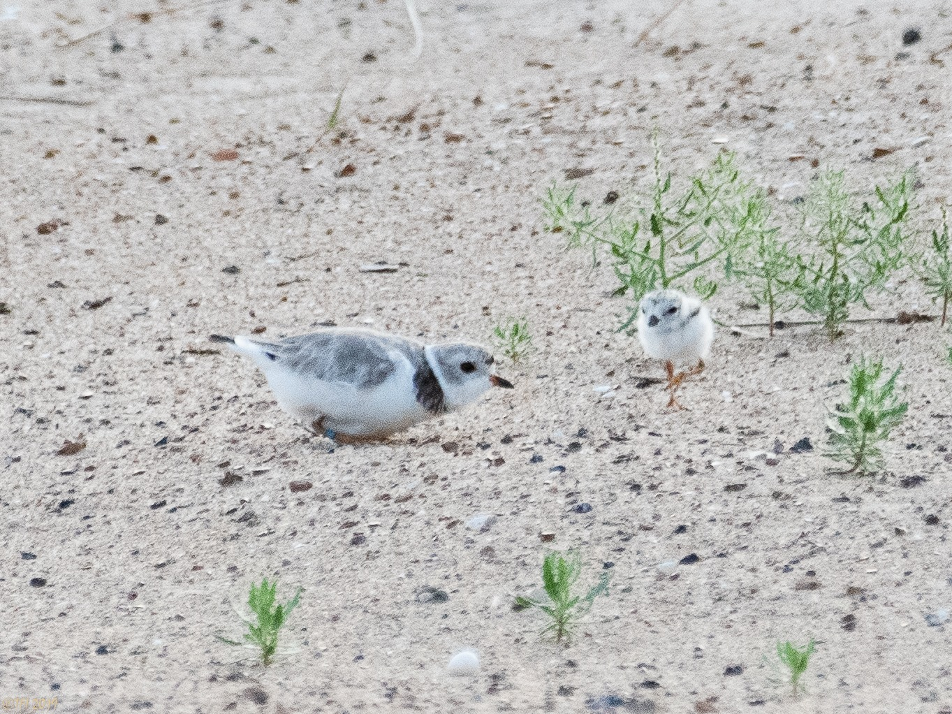

Susan Szesol Facebook Aug 4:

